Table of Contents

**What is web development? 1**

**What is the difference between front-end development and back-end development? 2**

**What is the difference between web development and web design? 2**

**Why is web development important? 3**

**Components of web development 3**

**The web development process 4**

**1. Develop a plan 5**

**2. Create a sitemap 5**

**3. Purchase a domain name 5**

**4. Build your backend 6**

**5. Build your front-end 7**

**6. Launch your website 7**

**WebFX offers superior web design and development services 7**

SOFTWARE DEVELOPMENT

* Software developers invent the technologies we sometimes take for granted. For instance, that app that rings, sings or buzzes you out of a deep sleep every morning? A software developer helped design. And when you roll into the office and turn on your computer, clicking and scrolling through social media, music and your personal calendar – developers had a big hand in shaping those, too.  
    
  You might spend your lunch break shopping, and before you make that big purchase, you check your bank account balance using your phone. Later, you cook a new recipe from that great app your friend told you about.
* As you look over the course of your day, you come to see that software developers are the masterminds behind the technologies you can't imagine living without.  
    
  The best developers are creative and have the technical expertise to carry out innovative ideas. You might expect software developers to sit at their desks designing programs all day – and they do, but their job involves many more responsibilities.
* They may spend their days working on a client project from scratch and writing new code. But they may also be tasked with maintaining or improving the code for programs that are already up and running.  
    
  Software developers also check for bugs in software. And although the job does involve extreme concentration and chunks of uninterrupted time, developers have to collaborate with others, including fellow developers, managers or clients.
* Developers are often natural problem solvers who possess strong analytical skills and the ability to think outside the box.  
    
  Software developers are employed in a range of industries, including computer systems design, manufacturing and finance.

The Bureau of Labour Statistics projects 25.7% employment growth for software developers between 2022 and 2032. In that period, an estimated 410,400 jobs should open up.

**What is web development?**

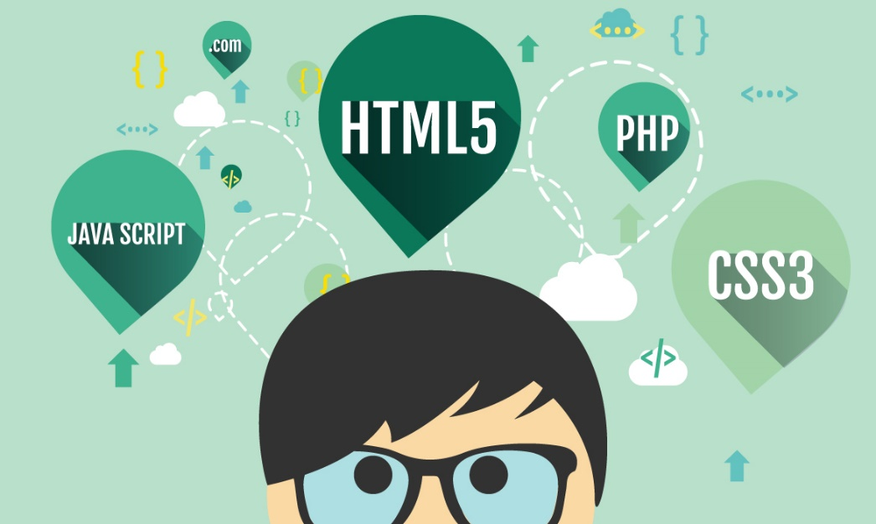Web development refers to the process of creating websites on the Internet.The term “web development” is relatively broad in its application. You could create a single website page from a [Wix template](https://www.webfx.com/web-design/tech/wix-landing-page-tips/), or you could painstakingly develop a massive website with thousands of original pages — and technically, both of those would count as web development.

**What is the difference between front-end development and back-end development?**

When you build a website, it’s a bit like designing a house. On the one hand, you want to look at painting the walls, installing the countertops, and laying the carpet. But beneath all that, you also need to lay out all the pipes and wires that enable your utilities to function.

Similarly, a website usually functions on two levels — front-end and back-end:

* Front-end development refers to the surface-level elements, the things you can see: Page format, color schemes, and so on.
* Back-end development is where you lay out all the behind-the-scenes, technical elements of your site. If your site features an image gallery, for example, you must store those image files somewhere — and back-end development is where you set up that storage space.

When you implement both front-end and back-end development on a website, it’s referred to as full-stack development.

**What is the difference between web development and web design?**

[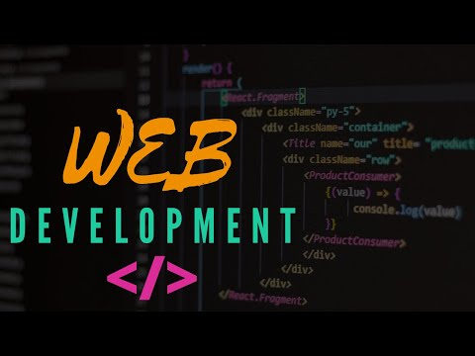](https://www.youtube.com/watch?v=xFMy0ixznjU)You may also have heard the term “[web design](https://www.webfx.com/web-design/learn/why-is-web-design-important/),” and [the two terms](https://www.webfx.com/blog/web-design/web-design-vs-web-development/) have a similar meaning. People tend to use “web development” to refer to more technical elements, and “web design” to refer to more visual or surface-level features. We have a video on [web design and development](https://www.webfx.com/blog/web-design/what-is-web-design-and-development/) if you’d like to learn more.

**Why is web development important?**

Web development is a critical element in any digital marketing campaign because your website lies at the heart of all your online marketing. Your [paid ads](https://www.webfx.com/blog/marketing/online-paid-advertising/), [social media](https://www.webfx.com/blog/web-design/how-social-media-works/), and [email campaigns](https://www.webfx.com/email-marketing/glossary/what-is-email-marketing/) ultimately lead users back to your site.

**Components of web development**

Before we dive into the steps of the web development process, you must know the major web development components that contribute to your website.

We’ll first look at what it means to build a website, and then we’ll examine some different types of web development processes. Read on to learn more!

**Website terminology**

When you engage in web development, you’re building a website — but what exactly does that mean?

The best way to answer this question is simply to run through some terminology. A website is a file stored on a server, which contains multiple websites. These servers are connected through the Internet.

When you visit a website, you visit it using a browser –– a program designed to load and display websites on your screen from servers. You may also hear browsers referred to as clients.

All this can be helpful to know when learning about web development, since much of the process centres around your browser and server.

**Hand coding vs. CMS**

When developing a website, you have two primary options for how to do it: Coding from scratch or use a website builder. When you code from scratch, you develop the entire website from the ground up. If you opt to use a website builder, you use a [content management system (CMS)](https://www.webfx.com/blog/internet/what-is-a-content-management-system/) to create it from a preexisting model.

A CMS gives you the basic building blocks of a website and lets you piece them together without having to know in-depth coding. In other words, the CMS handles the coding for you in advance — you just arrange the surface-level elements.

While using a CMS is very helpful if you don’t know anything about coding, hand-coding gives you the opportunity to create a more customized website for your business.

**The web development process**

When you’re ready to develop your website, you’ll want to follow a particular series of steps to ensure optimal results. For the next section of our web development overview, here’s a six-step description of the web development process!

**1. Develop a plan**

The first thing you should do before you develop a website is lay out a plan. Don’t just start throwing together a homepage right off the bat — take the time to figure out what you want for your site.

The best way to do this is to list specific goals. Some common goals are things like “allow users to buy our products on our site” and “educate users about our products and services.” You may also have goals like “familiarize users with our team members.”

Then, consider who you’re trying to reach with your site. Who will visit your site? What will they want to find? Throughout the rest of the development process, keep your goals and target audience at the forefront of your mind.

**2. Create a sitemap**

Once you’ve come up with some general goals, you can start planning the actual layout of your site. The best way to do that is to create a [sitemap](https://www.webfx.com/blog/web-design/content-mapping/), where you simply plan out all the different sections and pages that will make up your site (not to be confused with an [XML sitemap](https://www.webfx.com/blog/seo/what-is-an-xml-sitemap/)).

You can make a sitemap online, or you can simply use a pen and paper. You’re just trying to visualize how all the pages on your site will be organized and interconnected.

Ultimately, this sitemap will be the key to creating an effective [navigation setup](https://www.webfx.com/blog/web-design/choose-navigation-setup/) on your site, allowing users to easily find their way around it.

**3.** **Purchase** **a domain** **name**

The next step is to register a [domain name](https://www.webfx.com/blog/web-design/tools-for-picking-a-domain-name/). Your domain name is your site’s URL. For a business website, the best approach is to simply use your business name as your domain name.

You can search on a website like [GoDaddy](https://www.godaddy.com/) to see if your domain name is available. You may need to tweak and adjust your name to find an available domain. From there, you’ll need to choose a website host.

When creating a domain name, try to make it clearly associated with your brand, and keep it short if possible — longer domain names are harder for users to remember.

If you use a website builder like WordPress, you can also register your domain name through there.

**4. Build your backend**

As soon as you know the layout of your website, you can begin coding. As noted earlier, you may choose to use a CMS like WordPress to do this. If so, you can use preexisting building blocks or even templates to create your site, but bear in mind that your website won’t be as unique as it would if you built it from scratch. Or, check out our [WordPress web design services](https://www.webfx.com/web-design/services/wordpress/) and we’ll build it from scratch for you.

 Whatever you do, don’t just grab a template and change the words on the page. Templates should serve as a starting point, so you want to modify them into something new and original to help create a unique design.

If you decide to hand-code it, you’ll likely find yourself using three [web development tools](https://www.webfx.com/blog/web-design/web-development-tools/) — [HTML, CSS (cascading style sheets)](https://www.webfx.com/blog/web-design/should-web-designers-know-html-and-css/), and [JavaScript](https://www.webfx.com/blog/web-design/6-advanced-javascript-techniques-you-should-know/). All three of these programs enable you to build a website out of code, with HTML forming the building blocks and the other two tools enhancing the basic code.

Once your initial coding is done, you’ll want to start optimizing other elements of your back-end, which includes deciding where you’ll host your site and how it will be organized and retrieve data.

The process of back-end optimization is detailed and technical, but here are a few of the things you can expect to do:

* Set up forms to collect data
* Store image files
* Set up cookies on specific pages
* And more!

Back-end optimization is a very important step in the development process, particularly if users can make purchases on your site — the data they enter has to be stored somewhere.

**5. Build your front-end**

After building the back-end of your site, the natural next step is to move on to the front-end. That means setting up the part of your site that users will see when they visit it — the wallpaper and countertops to your website’s house.

If you use a CMS, you essentially skip right to this step, selecting color schemes and moving elements around on the page instead of coding your site. On the other hand, if you code from scratch, you must build your code first and then add elements to your website. Some common front-end elements include:

* Color schemes
* Font choices
* Navigation layout
* And more!

When you build your website, make your site is [user-friendly](https://www.webfx.com/web-design/glossary/what-is-ux-design/) and that you [brand yourself](https://www.webfx.com/blog/web-design/why-branding-yourself-is-important/) visually during this step.

**6. Launch your website**

With all the above steps completed, all that’s left for you to do is launch your site! Of course, you’ll want to run some tests to verify that everything on it is working properly first. But once you’re sure everything’s in order, you can make it public.

From there, you can continue updating and reoptimizing to help your site rank better in search and drive better results for your business.

**WebFX offers superior web design and development services**

Looking for help developing your business’s website? WebFX can give you a hand! With over 28 years of experience, we’re the experts when it comes to web design, and we’d love to help you drive results through your website.

WebFX has an [award-winning](https://www.webfx.com/about/awards/) web design team, and we possess an extensive [portfolio](https://www.webfx.com/portfolio/) of sites we’ve built.

With our [web design](https://www.webfx.com/web-design/services/) and [web development services](https://www.webfx.com/web-development/services/), you’ll get help with all the steps listed in the web development overview above.  We also offer clear web design and [web development pricing](https://www.webfx.com/web-development/pricing/) to ensure you know what to expect as you invest in your online presence. You’ll also receive a dedicated account representative to keep you up to date on everything we do for your website, so you stay fully in the know.

|  |  |  |  |  |  |  |
| --- | --- | --- | --- | --- | --- | --- |
| **Time Slot** | **Monday 27-01-2025** | **Tuesday 28-01-2025** | **Wednesday 29-01-2025** | **Thursday 30-01-2025** | **Friday 31-01-2025** | **Saturday 01-02-2025** |
| 09:50 AM to 10:35 AM | **2304CS202 - WD-II (Lecture)** {CKS} [Class Room - G-105] | **2304DU004 - OAT (Lecture)** {SVM} [Class Room - G-105] | **2304CS205 - OS (Lecture)** {HRC} [Class Room - G-105] | Batch-1 **2304CS204 - DBMS-I (Lab (TA))** {DCP, KAHANI, OM} [Computer Lab - H-409] | Batch-1 **2304CS204 - DBMS-I (Lab (TA))** {DCP, KAHANI, OM} [Computer Lab - H-409] |  |
| 10:35 AM to 11:20 AM | **2304CS201 - CP-II (Lecture)** {AGB} [Class Room - G-105] | **2304CS201 - CP-II (Lecture)** {AGB} [Class Room - G-105] | **2304DU002 - ES (Lecture)** {ACC} [Class Room - G-105] |  |
| 11:20 AM to 11:40 AM | Break | Break | Break | Break | Break | Break |
| 11:40 AM to 12:25 PM | **2304CS205 - OS (Lecture)** {HRC} [Class Room - G-105] | **2304CS204 - DBMS-I (Lecture)** {DCP} [Class Room - G-105] | **2304CS202 - WD-II (Lecture)** {CKS} [Class Room - G-105] | **2304CS205 - OS (Lecture)** {HRC} [Class Room - G-105] | **2304CS204 - DBMS-I (Lecture)** {DCP} [Class Room - G-105] |  |
| 12:25 PM to 01:10 PM | **2304DU004 - OAT (Lecture)** {SVM} [Class Room - G-105] | **2304DU002 - ES (Lecture)** {ACC} [Class Room - G-105] | **2304CS204 - DBMS-I (Lecture)** {DCP} [Class Room - G-105] | **2304CS202 - WD-II (Lecture)** {CKS} [Class Room - G-105] | **2304CS201 - CP-II (Lecture)** {AGB} [Class Room - G-105] |  |
| 01:10 PM to 02:10 PM | Break | Break | Break | Break | Break | Break |
| **02:10 PM to 02:55 PM** | Batch-1 **2304CS201 - CP-II (Lab (TA))** {AGB, VISHAL, VIDIT} [Computer Lab - H-205] | Batch-1 **2304CS202 - WD-II (Lab (TA))** {CKS, SURAJ, PRASHANT} [Computer Lab - H-404] | Batch-1 **2304DU004 - OAT (Lab (TA))** {SVM, RAJ, DARSHI} [Computer Lab - H-205] | Batch-1 **Library** | Batch-1 **2304CS205 - OS (Lab (TA))** {HRC, KARTIKEY, VANSHI} [Computer Lab - H-409] |  |
| **02:55 PM to 03:40 PM** |
|  |

**Darshan Institute of Computer Applications**